Revision history
Rev | Date | Originator(s) | Change Details
A | Nov 11, 2020 | Andreas Bock | First issue

System requirements

Do not operate a damaged unit!
- Client Windows/Mac/UNIX-PC with ssh-client and Web browser installed and LAN/WIFI interface
- Jabil Orbital sensor with power supply (included)
- LAN cable (included)
- DHCP LAN infrastructure to connect the Client PC and Jabil Sensor
- Small flat head screwdriver to remove power supply cable
- Safety glasses for 850nm (included)

Setup and power up the unit

Connect power supply:
- Only connect the power supply that came with the unit


- AC power input from 100-240V is supported.
- Different wall plug adapters are delivered together with the power supply.
- Do not plug in the power supply in the wall socket until the connection to the unit is set correctly.
- Connect the power supply in the following way:

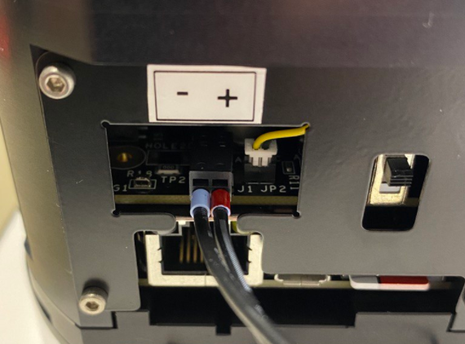

Red marked wire is 24V(+)
Blue marked wire is GND(-)
- Push the ferrule carefully in the lower hole of the connector and make sure that the wire is locked correctly by pulling it carefully.

- To release a wire insert a flat head screwdriver with max. 1.5mm width in the upper opening of the connector, push the screwdriver and pull the wire carefully at the same time. The wire should come off easily.

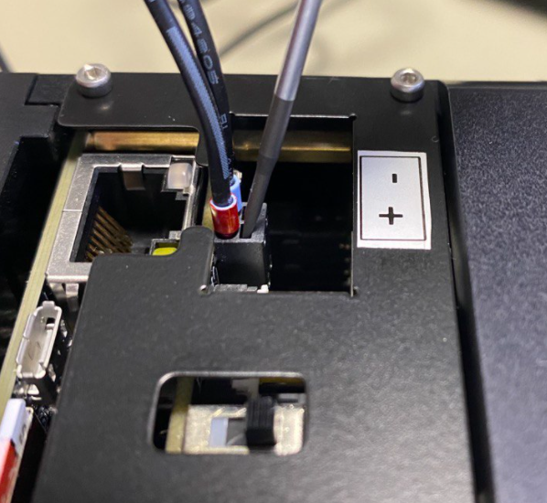
- After the power supply is correctly connected to the unit, plug in the power supply into the wall socket. Make sure the Power switch is in the upper (OFF) position.

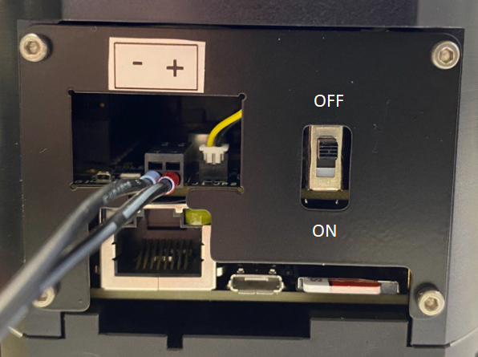

Power up the unit
- Before powering up the unit make sure that:
  - All protective foils from the lens and illumination window were removed.
  - All conditions were met to safely operate the laser unit.
  - The unit is not covered in any way to ensure proper cooling and heat dissipation.
  - The delivered SD card is still in the SD card slot.

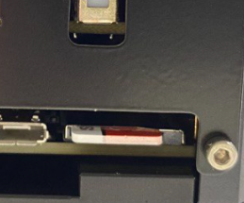

PUT ON SAFETY GLASSES

- Move the power switch to the lower (ON) position.

- The green status LED on top of the unit should light up immediately. The green LED indicator is only (ON) when power is supplied to the unit. If the green LED isn’t illuminated (OFF), power isn’t supplied to the unit. This is a good reference for laser safety.

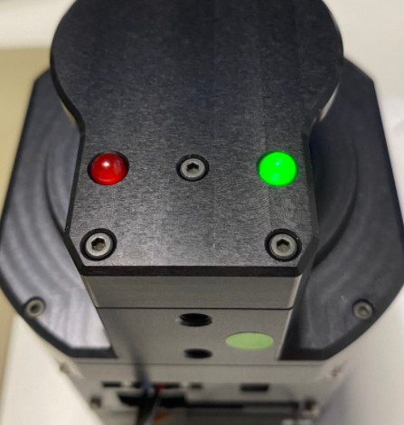

- The unit starts booting.
- During the boot process the yellow LED on the Ethernet connector should light up at least one time.

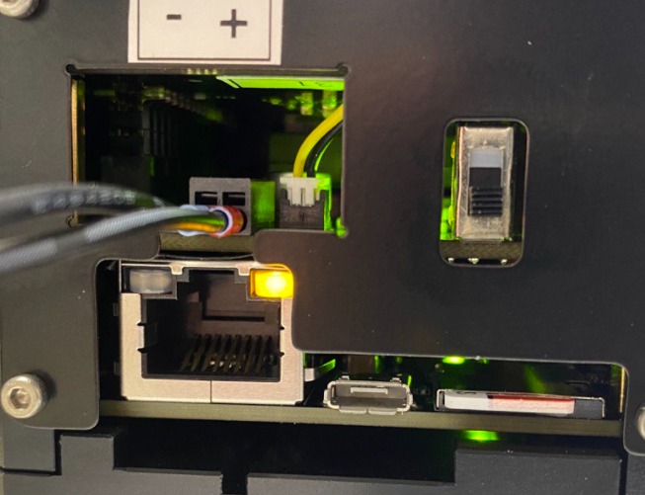

- After approximately 20s the red status LED on top of the unit will illuminate (ON) – both status LEDs are now (ON).

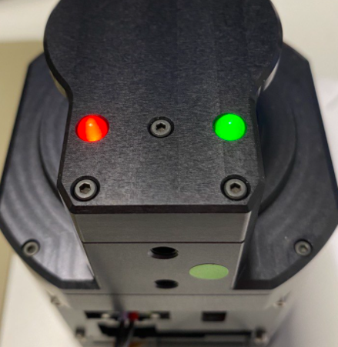

- The system was successfully booted.

Please keep in mind: as soon as the RED LED is (ON) the unit is ready to
emit laser light to its environment at any time!

Connect the unit to a LAN
The following conditions must be met to connect the unit to a LAN:
- The LAN must support at least 1Gbit/s bandwidth
- The LAN must have a DHCP server running which is able to assign IPs to new connected Ethernet devices.
- Connect the LAN cable provided with the unit came to the Ethernet socket.
- Make sure the Client-PC is connected to the same DHCP server in the same IP range.

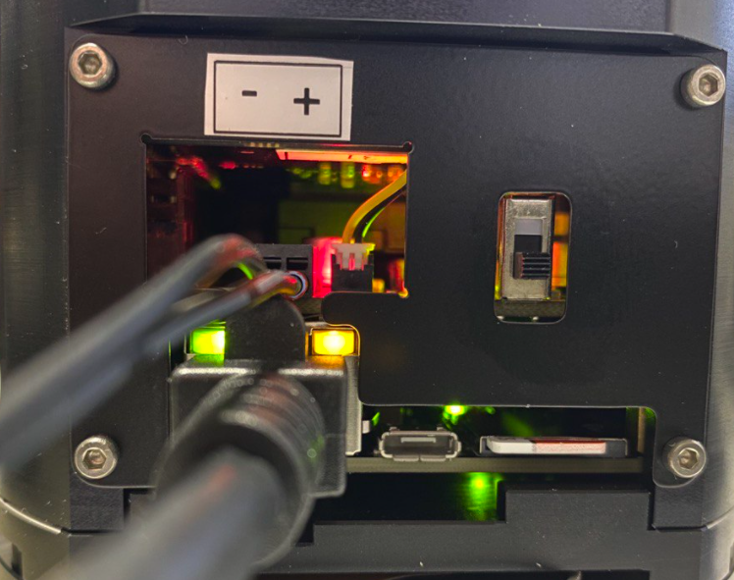
- Both Ethernet status LEDs should be (ON) to indicate a successful link to the network.
- Note the IP address of the unit which was assigned by the DHCP server. Most probably the DHCP server user interface will provide the information. The device will show up as an “imx8mm-var-dart” device with IP 192.168.188.38 as shown in the image below. The IP range can be completely different depending on the DHCP settings.

Login into the unit
The unit has a ssh-Server running to enable the user to login into the system.
- Use any available ssh-Client (like PuTTY) to login into the system
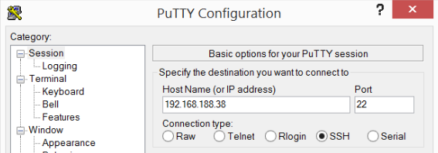

- A Unix command line will show up.
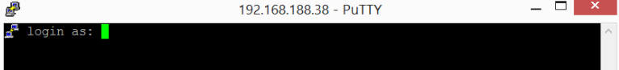

- Please login with the user “root”.
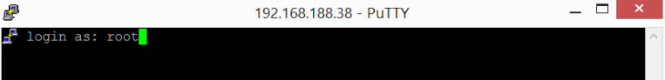

- When the login was successful the units command line appears.
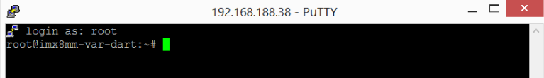

- Please type the following command to start the latest version of the Sensor application.
/usr/local/chiton/current/chiton

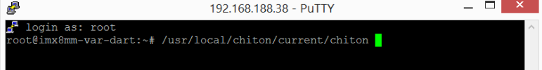

- The following text will show up and the Sensor application will start.

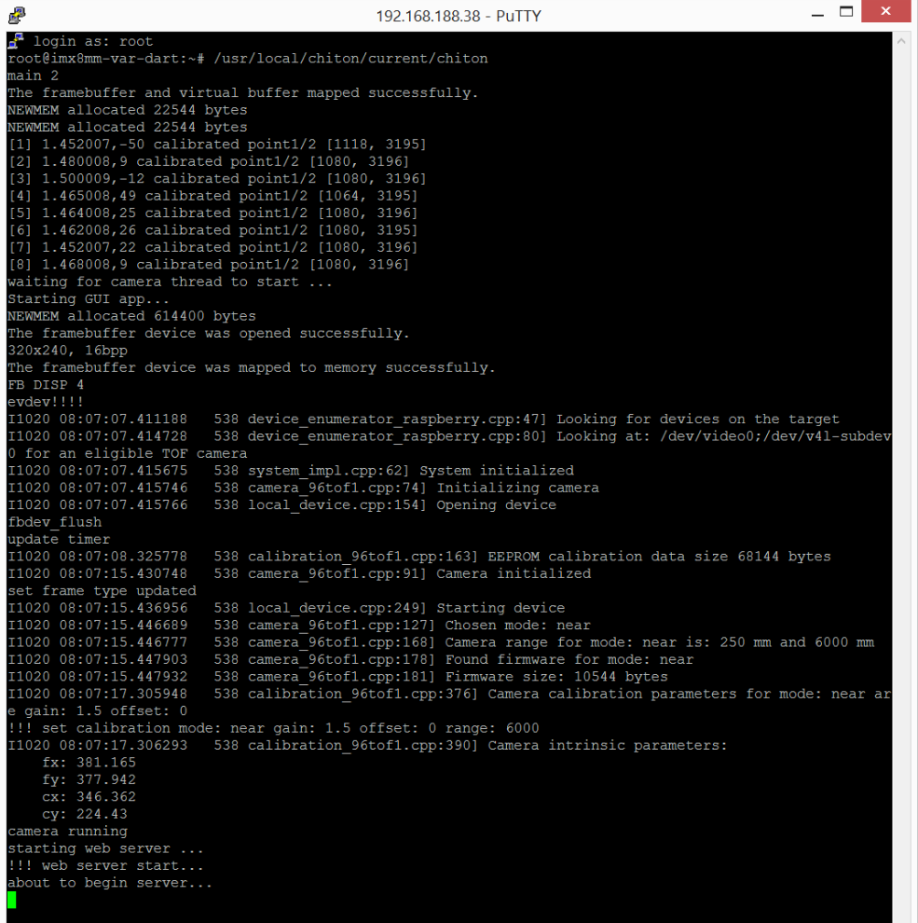

- Open a Web browser on the Client-PC and type the unit’s IP address in the address field.

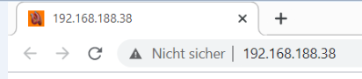

- The following GUI of the Jabil orbital sensor will load.

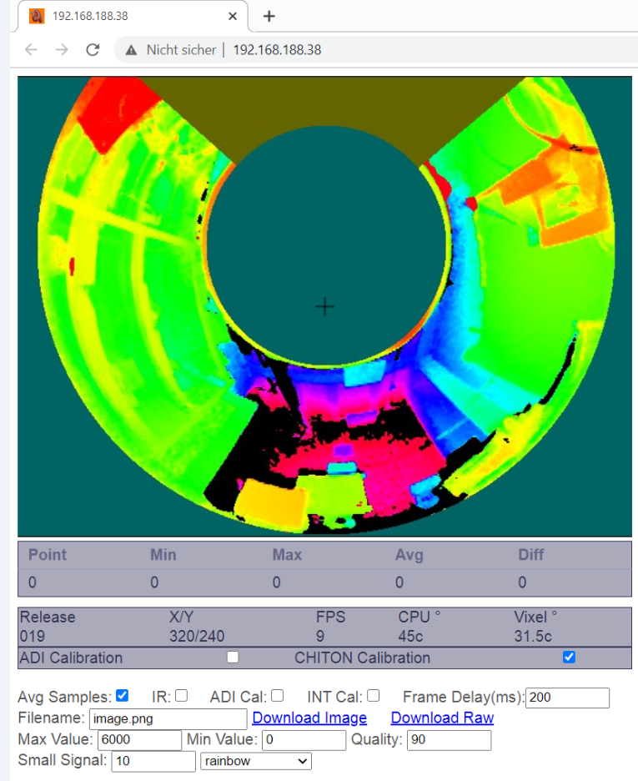

- The Jabil Orbital sensor is delivering a live stream of data to the Client-PC.
- For more details about the GUI and its functions please refer to section 3 - User interface.

Note: The GUI may be different based on the software release on the SD card

Wifi Start Up (if LAN is unavailable and SD card was shipped before Nov 10)
Requires a LINUX Machine
- Remove SD Card from the backside of the unit
- Insert card into an SD Card reader connected to a Linux computer
NOTE: Edit the following files on the SD Card, not on the local computer. If familiar with Linux, the SD card needs to be mounted.
- Create the file wifi.sh
/etc/wifi.sh file
- Insert the following script
#!/bin/sh
nmcli r wifi on
nmcli d wifi connect <wireless network name> password <‘password’
Example for last line: nmcli d wifi connect boisenetwork password ‘boise’ where boisenetwork is the wifi network name and boise is the password

- While mounted to SD Card run the following file to retrieve and the load the most recent release:
/path to SD card on local machine/upgrade.sh 024 (refer to the wiki for latest release number. In the example, 024 is the latest release.)
- Run following command /etc# chmod +x /etc/wifi.sh
The command line would look like: root@imx8mm-var-dart:/etc# chmod +x /etc/wifi.sh
- Edit the file rc.local using the following line
/etc# vim /etc/rc.local
Add the following line to end of the file: /etc/wifi.sh
The file will look like:
Echo 30000 > /proc/sys/vm/min_free_kbytes
/usr/local/chiton/current/tft_device.sh
/usr/local/chiton/current/tft_device.sh
/usr/local/chiton/current/mkgpio.sh
/etc/wifi.sh
exit 0
- See 2.4 Login Into the Unit following completion of the previous steps

User interface

GUI elements

UI element | Description
Live stream window | The live stream data will be provided in this part of the GUI with up to 30FPS
Crosshair | The crosshair marks the currently active measurement point
Point | Distance value of the actual frame of the crosshair measurement point
Min | The minimal distance value of the last 20 frames of the crosshair measurement point (rolling window)
Max | The maximal distance value of the last 20 frames of the crosshair measurement point (rolling window)
Avg | The average distance value of the last 20 frames of the crosshair measurement point (rolling window)
Diff | The difference of maximal distance value and minimal distance value of the last 20 frames of the crosshair measurement point (rolling window)
Release | Currently active software release
X/Y | X-Pixel and y-Pixel locations of the Crosshair
FPS | Currently transferred frames per second (up to 30 FPS).
CPU° | Sensor CPU temperature in °C
Vicsel° | Sensor VCSEL temperature in °C
ADI calibration | Enables and disables the ADI calibration method in the SDK software block (single point calibration).
CHITON Calibration | Enables and disables the CHITON calibration method in the SDK software block (8-segment calibration).
Avg Samples | Enable/disable the averaging of the frames
IR | Toggle between depth and intensity images
ADI Cal | Not used at moment
INT Cal | Not used at moment
Frame Delay (ms) | Defines a delay between transferred frames and adjust the frame rate of the live stream in lower performance networks.
Filename | Filename of the .png image file while downloading
Download Image | Download an .png image of the current transferred frame.
Download Raw | Download the raw image data of the sensor (see section 4.2 RAW data handling)
Max Value | Maximum distance/intensity for the colour coding. Pixels above this value appear black.
Min Value | Minimum distance/intensity for the colour coding. Pixels below this value appear red.
Quality | jpg Image compression of the live stream data on the webpage to adjust the bandwidth of the live stream in lower performance networks.
Small Signal | Small signal suppression will cut off very small values to remove visible noise in the image.
Rainbow/greyscale dropdown | Switch between colour coded or greyscale depth/IR image view.

RAW data handling
When clicking the “Download Raw” Link in the GUI a RAW file will be requested at the sensor and is ready for download. A file named “camera” will be downloaded, without file extension.
Note, the RAW data contains the distance values after calibration and applied corrections.
To open and analyze the RAW data an image tool (e.g. ImageJ https://imagej.net/Welcome) is needed.
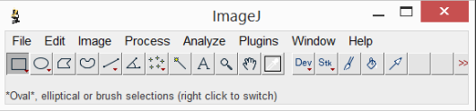
Import the RAW file with the following settings.
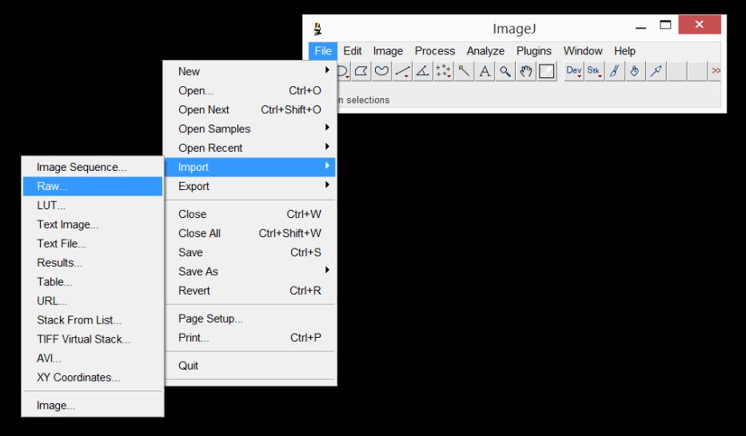
Image type: 16-bit Unsigned, 640x480 pixel, offset 0, number of images 1, Little-endian byte order
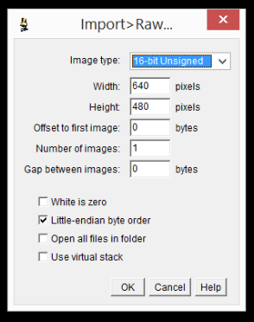

ImageJ will find the min and max value in the imported image and will adjust the visible range accordingly. Sometimes very bright spots are visible in the image and therefore many smaller distance areas are faded into black. Please adjust the Maximum slider from 65565 to something in the 8000 area to get a clearly visible image.
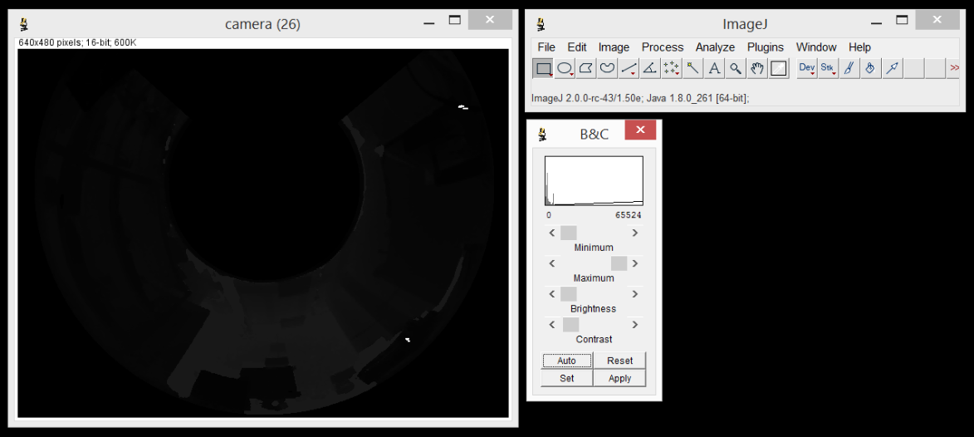
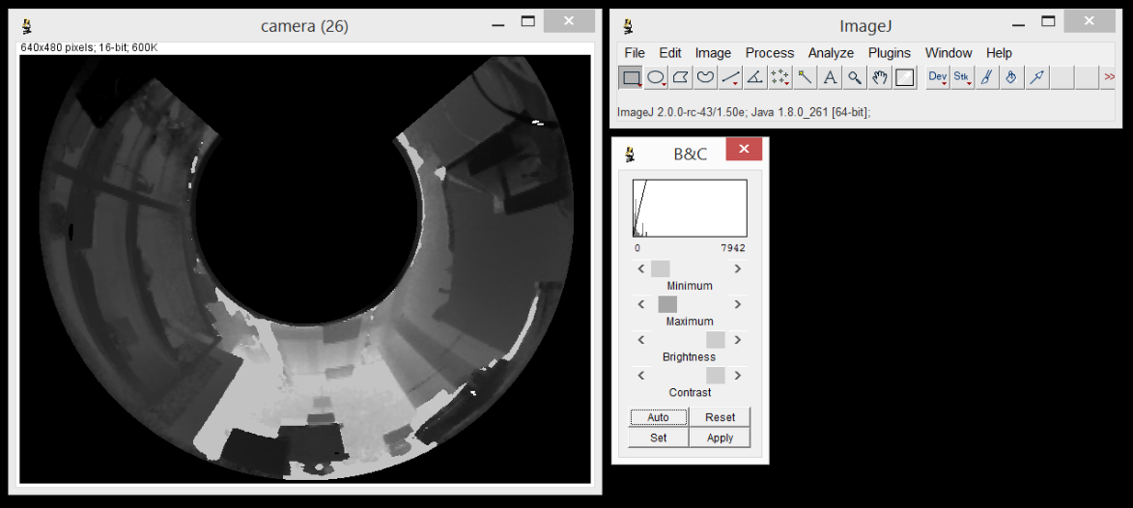

Data Analysis
To analyze the RAW data captured by the sensor, access the RAW data through the Link provided in the GUI, by virtually clicking the “Download Raw” Link.
This is an example how to get the RAW data in a Python script and read out the distance data for a specific X1, Y1 pixel coordinate.
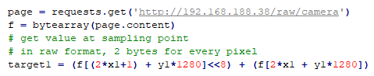

Further Information

Contact details
Contact Details BD
Company | Jabil Optics
Contact person | Ian Blasch
Phone | 650-776-8803 (USA)
E-mail | Ian_Blasch@jabil.com
Contact Details SW
Company | Jabil Optics
Contact person | Cory Marsh
Phone | 208-340-7070 (USA)
E-mail | cory@bitslip6.com
Contact Details System
Company | Jabil Optics
Contact person | Andreas Bock
Phone | +4936412271254 (Germany)
E-mail | Andreas_Bock@jabil.com

